
Enter Course Name
Enter Course Number
Instructor Guide
Enter Month and Year

Enter Course Version


NTED Branded Disclaimer
Notes for Using This Template
This template is designed to provide a foundation for developing Section 508 compliant course documents. Course content should be developed in the template following best practices in accessible document design.
The cover uses content control boxes for the course name, course number, date, and version to preserve the formatting. The font size can be adjusted as needed for longer course titles.
The cover graphics (with the exception of the FEMA logo) as well as the header and footer graphics are marked as decorative. If you are using an older version of Microsoft Word the Mark as Decorative feature may not be available and these items will need to be manually marked as decorative by using the null tag (“ “) in the alt text pane.
If Microsoft Word is the FINAL format for your documents, do not include complex tables (i.e., tables with merged cells or multiple headers) and format all non-decorative objects as in-line with text. The logo on the cover page is correctly set to appear in-line; please use the line spacing settings to adjust it to its proper place in the lower corner once your cover information is in place.
Please delete this text box prior to finalizing the document.


This program was supported by Cooperative Agreement Number xxxx-xx-xx-xxxx, administered by the U.S. Department of Homeland Security, National Training and Education Division. Points of view or opinions in this program are those of the author(s) and do not represent the position or policies of the U.S. Department of Homeland Security.
FEMA’s National Training and Education Division (NTED) offers a full catalog of courses at no cost to help build critical skills that responders need to function effectively in mass consequence events. Course subjects range from Weapons of Mass Destruction (WMD) terrorism, cybersecurity, and agro-terrorism to citizen preparedness and public works. NTED courses include multiple delivery methods: instructor led (direct deliveries), train-the-trainers (indirect deliveries), customized (conferences and seminars), and web-based. Instructor led courses are offered in residence (i.e. at a training facility) or through mobile programs, in which courses are brought to state and local jurisdictions that request the training

Table of Contents
NTED Branded Disclaimer i
Table of Contents iii
[Enter Lesson Title] - Administration Page (Optional) 1
Duration 1
Scope Statement 1
Terminal Learning Objectives (TLO) 1
Enabling Learning Objectives (ELO) 1
Resources 1
Instructor to Participant Ratio 1
Reference List 1
Practical Exercise Statement 1
Assessment Strategy 1
Instructor’s Note: 1
[Enter Course Title] 2
Icon Map 2

[Enter Lesson Title] - Administration Page (Optional)
[Duplicate the following three pages for each lesson. Please delete this paragraph prior to submitting the document for review.]

Duration
[Enter lesson duration.]

Scope Statement
[Enter scope statement.]

Terminal Learning Objectives (TLO)
[Enter the TLO.]

Enabling Learning Objectives (ELO)
[Enter the ELOs.]

Resources
[Enter the lesson resources.]

Instructor to Participant Ratio
[Enter the instructor to participant ratio(e.g., 1:25).]

Reference List
[Enter the reference list.]

Practical Exercise Statement
[Enter the practical exercise statement.]

Assessment Strategy
[Enter the assessment strategy information.]

Instructor’s Note:
[Enter instructor notes as appropriate.]

[Enter Course Title]

Icon Map
Knowledge Check: Used when it is time to assess the learners’ understanding
Example: Used when there is a descriptive illustration to show or explain
Key Points: Used to convey essential learning concepts, discussions and introduction of supplemental material
 Hint: Used to cover administrative items or instructional tips that aid in the flow of the instruction

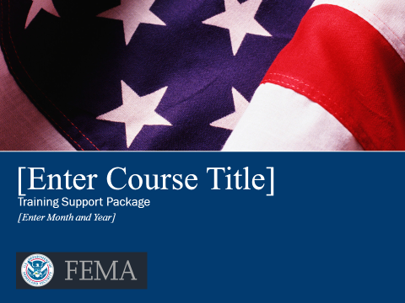
Slide 1. Slide Example
[Enter course content.]
- Bullet Level 1
- Bullet Level 2

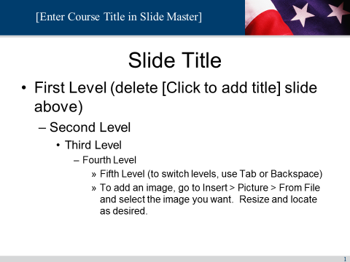
Slide 2. Slide Example
[Enter course content.]
- Bullet Level 1
- Bullet Level 2

